**Title:** Date: 29-10-2018

Investigation on Oxygen blending in bubble CPAP.

**Background and Problem statement:**

This open CPAP system consists of two inlet channels; air compressor & Oxygen source. The O2 containers that is supplied to the hospitals contains very high internal pressure that can rupture and cause leakage to the breathing circuit. In order to supply required level of Oxygen in the breathing circuit without breaking the functionality of the circuit, an experimental setup is created to find out the required apparatus/ tools, optimum pressure and flow rate for oxygen blending.

**Materials:**

This experiment has been done as a part of the respiratory circuit of the bubble CPAP. It includes the following parts:

1. Air compressor (45 lpm, 18 kPa) - qty. 1
2. Medical grade O2 cylinder (10 ltr. Capacity, B-Type bullnose connector, internal pressure 115 kg/sq.cm) - qty. 1
3. Oxygen FA Valve with Rotameter & Humidifier Bottle (single stage single gauge valve, iteration 1) - qty. 1 (replaced with item no. 4 in final iteration)
4. Oxygen FA Valve with Rotameter (single stage double gauge valve, final iteration) - qty. 1
5. Flowmeter (Pin type control valve, 1-10 lpm) - qty. 2
6. Y-connector for tube ID 3/8 inch (9.5mm) - qty. 1
7. HME filter with connector assembly for tube ID 8mm or 9.5mm. Qty. 1 set
8. Silicon tubing (ID - 8mm, OD - 12mm, autoclavable)
9. Humidifier (non bubbling. Box type or standard medical grade humidifier)
10. Flowmeter (without control valve, 1-10 lpm) - qty. 1
11. Digital manometer (Max range 5 PSI, Differential pressure 20 PSI)

**System Diagram:**

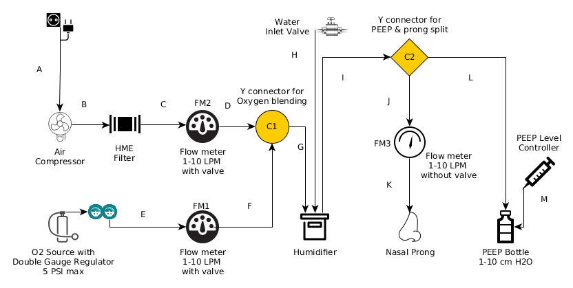

*Fig.1: System diagram for Oxygen blending*

**Testing Method:**

To test the oxygen blending and concentration in the CPAP system by using the mentioned apparatus, flow meter readings are taken under consideration. I.e. the combined flow of the air & O2 inlets are calculated in ratio to determine the probable concentration of oxygen in the circuit.

First, the circuit is constructed as shown in Fig.1 making sure that there are no leakage in the junctions. There are two parallel inlets i.e. air and oxygen vents. Both of the sources are connected via pin valve regulated flow meters.

The air input pipe consists of HME filters in order to remove particulates and other micro materials from the air & supply clean air to the system. HME filter comes with 3 pcs assembly & the junctions need to be fitted properly to prevent leakage. 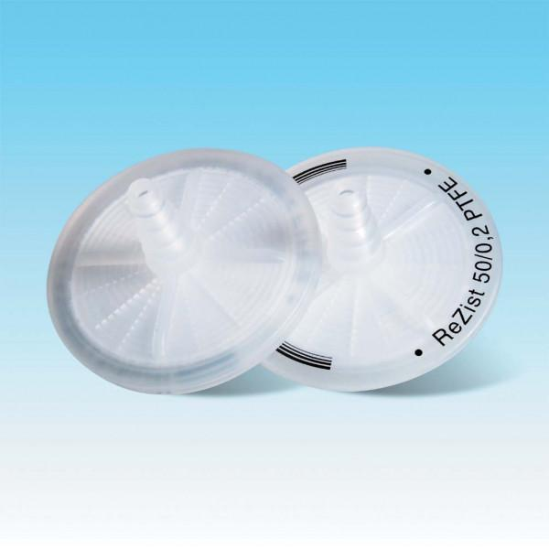 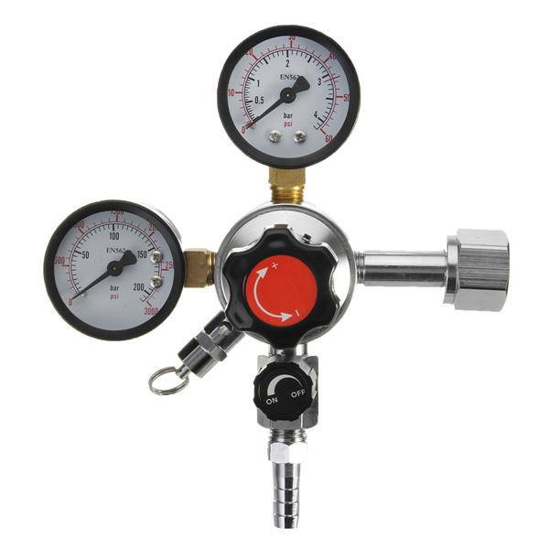

*Fig.2: Disc HME filter Fig.3: Single stage dual gauge valve w/o Humidifier*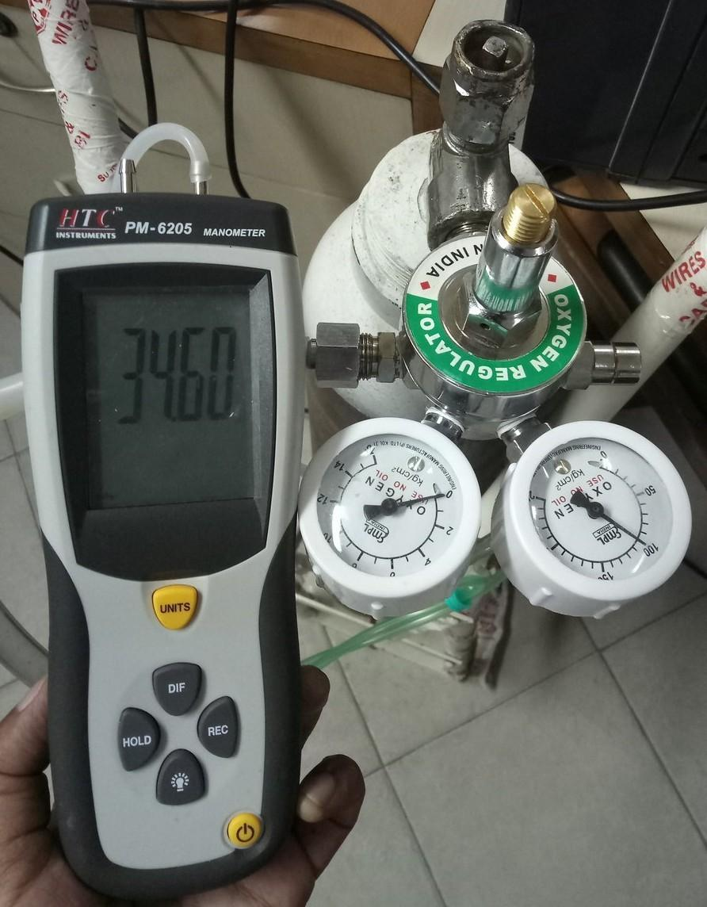

Dual gauge FA valve is used with high pressure oxygen cylinders. It has two gauge, one for measuring the internal pressure of the cylinder (0-150 kg/sq.cm) and the other is for maintaining in-circuit oxygen pressure (0-10 kg/sq. cm). A digital manometer is used to set the O2 output pressure at 34.5 kPa (5PSI) since this is found to be the optimum pressure level that does not affect the circuit junctions and shows best results during the flow ratio calculation. The exit valve is connected to the O2 flowmeter at the set output pressure.

The combined flow of these two sources are then blended though a Y-connector and fed to the humidifier. After humidification the air mixture is passed through the third and final flowmeter (non-valve type).

*Fig.4: Setting O/P pressure*

**Test Results:**

Pressure Levels

* Air compressor: 18 kPa (manufacturer specified)
* Oxygen input pressure 34.5 kPa max.

Blending table

|  |  |  |  |
| --- | --- | --- | --- |
| Air flow rate (Valve regulated) | O2 flow rate (Valve regulated) | Total flow rate (non-Valve) | Error (lpm) |
| 1 | 1 | 1.5 | -0.5 |
| 2 | 2 | 3.5 | -0.5 |
| 3 | 3 | 6 | 0 |
| 4 | 4 | 9 | +1 |
| 5 | 5 | Max. out | +1 |

*Table 1: Air-oxygen blending concentration*

**Analysis:**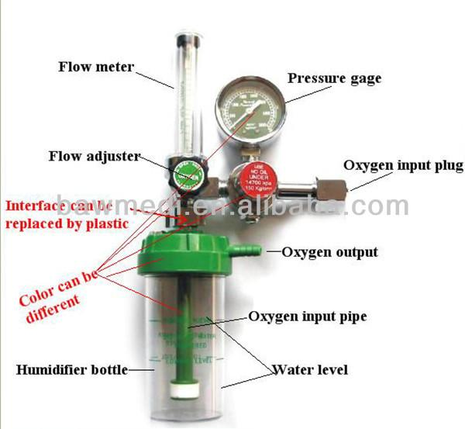

Valve selection & blending parameters are observed in this experiment. In the first iteration single gauge valve with humidifier is used. Pre humidified O2 flow is one advantage of using this valve but this type of valve has a severe impact on the respiratory circuit since it has no fine control over the pressure, the valve only deals with flow rate acting at the full internal pressure level of the oxygen cylinder; in our case which is 115kg/ sq.cm.

In our experiment it is found that such high pressure is easily capable of rupturing the tube connector junctions when the O2 output flowmeter (FM1) is set to zero and the built-in O2 regulator is turned ON.

*Fig.5: Single gauge FA valve*

In contrast, single stage dual gauge valves are designed for handling such conditions. It has pressure step-down feature that comes handy while operating oxygen blending at or below 5 PSI.

The non-linearity observed in the test results is due to different diameters of tubes and connectors. Results can be more accurate if uniform tube assembly is used.